**AI Assignment - Task 2**

E23011006 – Rufi Aliyev

E23011004 – Rza Mirzayev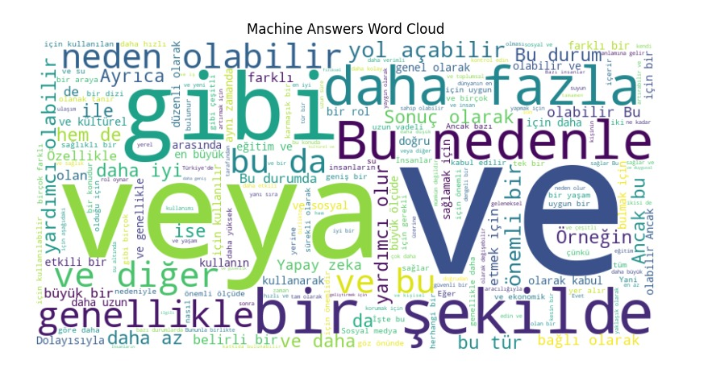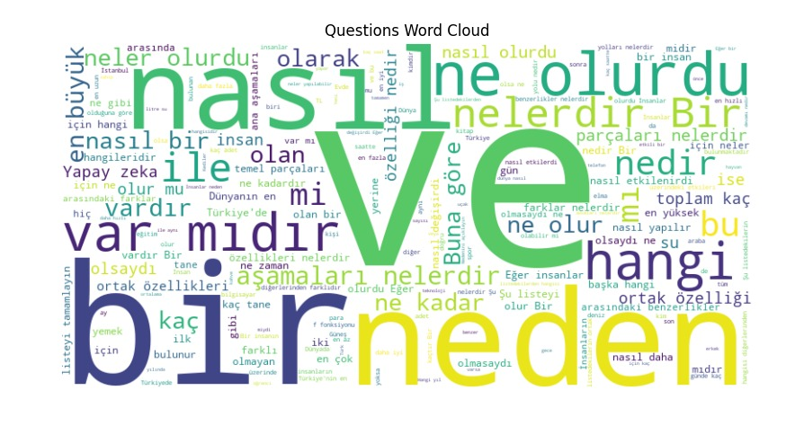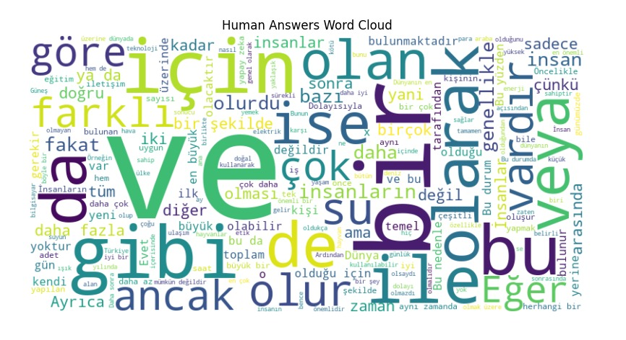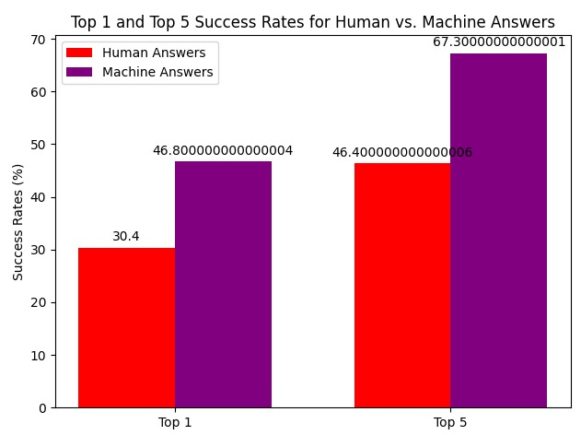

**1)** The table compares the success rates of human and machine answers in correctly identifying the top 1 and top 5 most similar answers to a given question. The machine outperforms humans in both metrics, with higher success rates for both top 1 and top 5.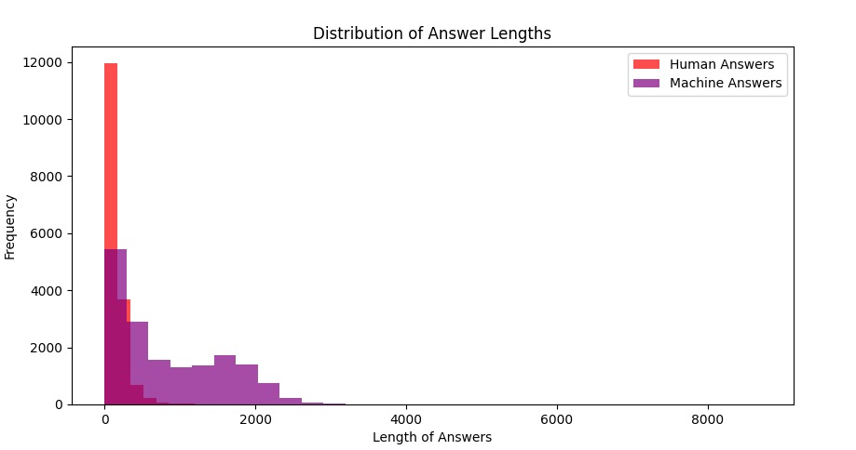

**2)** The table illustrates the distribution of answer lengths for both human and machine answers. Human answers tend to be shorter, with a significant drop in frequency as the length increases. In contrast, machine answers show a more gradual decline in frequency with increasing length.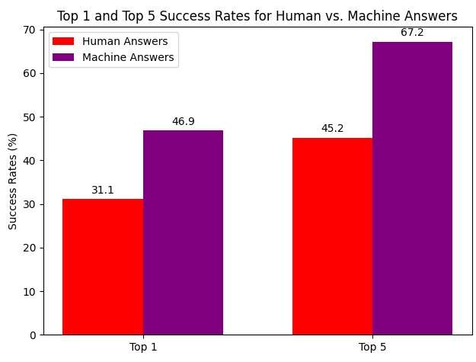

**3)** This table presents the success rates of human and machine answers in identifying the top 1 and top 5 most similar answers to questions, as represented in a heatmap. The heatmap visualization provides a clear comparison of success rates between the two methods.

These findings indicate that while humans are effective in providing accurate answers, machines exhibit a higher success rate, particularly in identifying similar answers among a larger pool of options. Further analysis is recommended to explore the factors contributing to the differences in performance between human and machine answers.

For the code please check next folder “AI_Tester” ;)